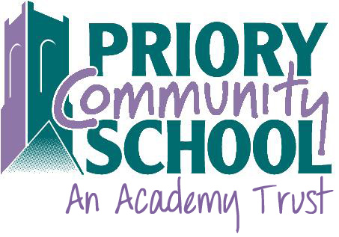

PRIORY COMMUNITY SCHOOL

GCSE RESULTS 2018

GCSE English and maths grade 4 or above 59%

GCSE English and maths grade 5 or above 37%

Attainment 8 43.27

Progress 8 -0.24

English Baccalaureate 20%

English Grade 4+ 66%

English Grade 5+ 46%

Maths Grade 4+ 70%

Maths Grade 5+ 43%

